Circle of Fifths
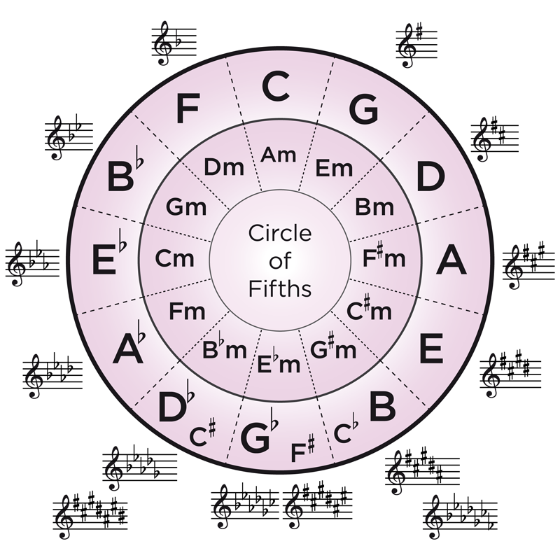

DO is tonic in Major.
LA is the tonic in Minor.
Major Poles are SOL and DO
Minor Poles are MI and LA.

The last flat is FA.
The last sharp is TI.
The order of Sharps:F# C# G# D# A# E# B#
The order of Flats: Bb Eb Ab Db Gb Cb Fb

Every key signature as two options: 1 Major Key and 1 Minor Key

